Data Structure and Algorithm

Laboratory Activity No. 5

Implementation of Arrays

|  |  |
| --- | --- |
| *Submitted by:* | *Instructor:* |
| Eulin, Ryan Bertrand B. | Engr. Maria Rizette H. Sayo |

08/16/25

# Objectives

Introduction

Array, in general, refers to an orderly arrangement of data elements. Array is a type of data structure that stores data elements in adjacent locations. Array is considered as linear data structure that stores elements of same data types. Hence, it is also called as a linear homogenous data structure.

This laboratory activity aims to implement the principles and techniques in:

* Writing algorithms using Array data structure
* Writing a python program that can implement Array data structure

# Methods

* Write a Python program to create an array of 10 integers and display the array items. Access individual elements through indexes and compute for the sum.
* Write a Python program to append a new item to the end of the array. Original array: numbers = [1, 2, 3, 4, 5, 6, 7, 8, 9, 10]
* Write a Python program to insert a new item before the second element in an existing array. Original array: numbers = [1, 2, 3, 4, 5, 6, 7, 8, 9, 10]
* Write a Python program to reverse the order of the items in the array. Original array: numbers = [5, 4, 3, 2, 1]

Write a Python program to get the length of the array. Original array: numbers = [5, 4, 3, 2, 1]

# Results

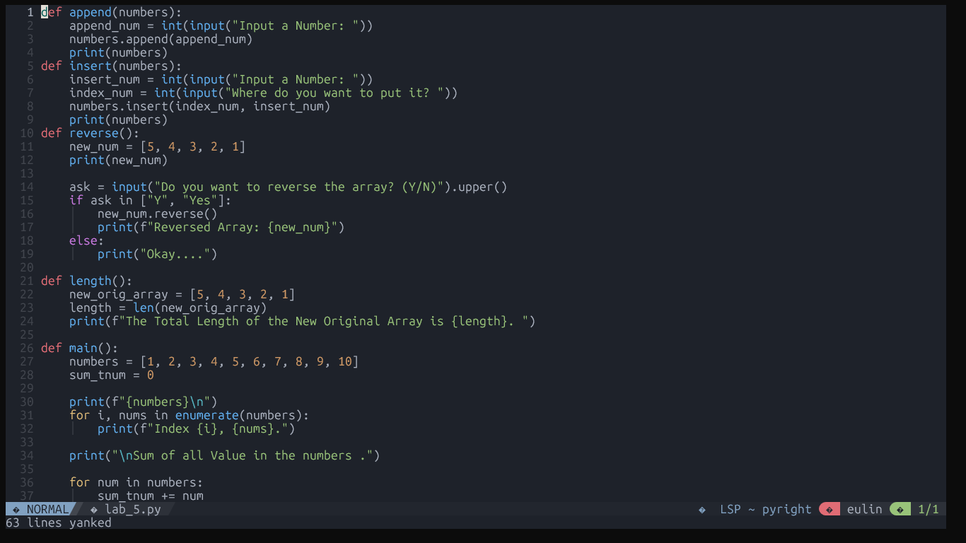

Figure 1

Source Code

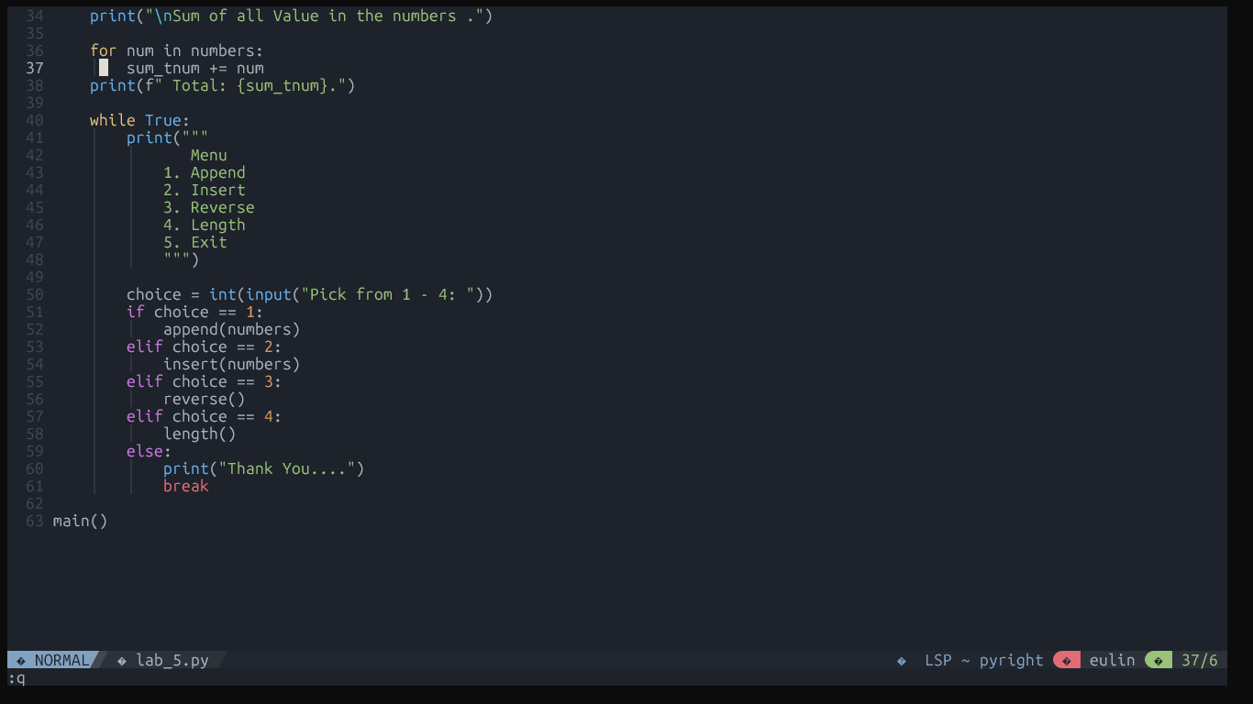

Figure 2

Source Code (2)

This is the Final Source code of the Program I created and I merge all the task needed in the method where in we have Append, Insert, Reverse and The Length of the Array.

Figure 3

Array and Sum

Figure 4

Append

Figure 5

Insert

Figure 6

Reverse

Figure 7

Length

Figure 8

# Conclusion

The conclusion expresses the summary of the whole laboratory ad first created in terminal then paste to Google collab. The student learns to Append, Insert, Reverse and check the length of the given array and can be used in different problems using python as the programming language it may differ in some programming language since, python have it’s own built in function like the Append, Insert, Reverse and the length.